**Creare proiect**

**Metoda I**

1. Adaugam dependentele in pom.xml

<dependency>  
 <groupId>com.fasterxml.jackson.core</groupId>  
 <artifactId>jackson-databind</artifactId>  
 <version>2.14.0</version>  
</dependency>  
<dependency>  
 <groupId>javax.servlet</groupId>  
 <artifactId>javax.servlet-api</artifactId>  
 <version>3.1.0</version>  
</dependency>

1. Cream un configuration class, in loc de XML, caci e mai usor., si avem nevoie anume de el aici.

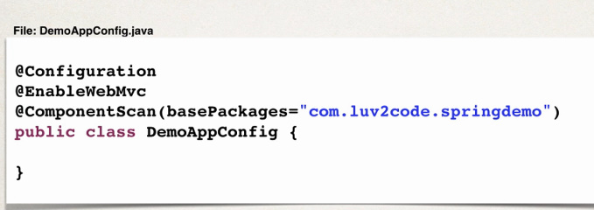

1. Cream un Servlet Initializer

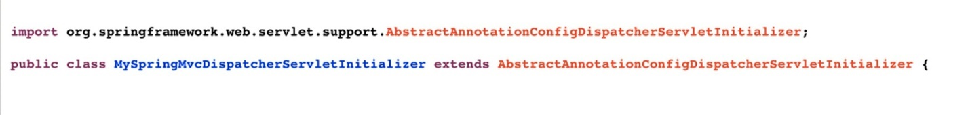

Aceasta clasa abstracta care e extinsa are metode ce trebuie suprascrise neaparat.

1. SupraScriem metodele:

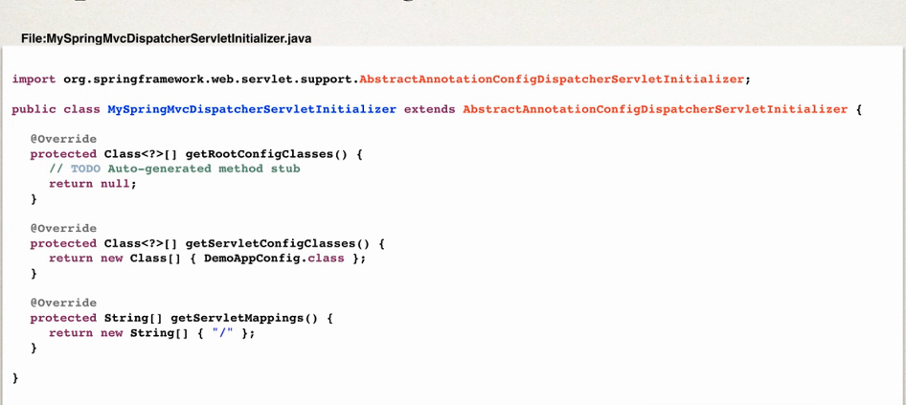

Nu avem rootConfig, deci returma null

ServletConfigClasses e clasa noastra care e configuration

ServletMapping aici e pentru toate requesturile

1. Cream Spring Rest Service

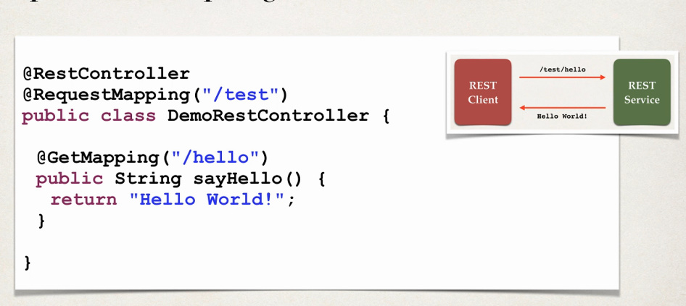

ATENTIE! In web.xml avem in mod default creat un dispatcher servlet! Trebuie sters ca sa nu avem 2.Noi deja am creat unul.

**Deci, in web.xml stergem:**

<servlet>  
 <servlet-name>dispatcher</servlet-name>  
 <servlet-class>org.springframework.web.servlet.DispatcherServlet</servlet-class>  
 <load-on-startup>1</load-on-startup>  
</servlet>  
<servlet-mapping>  
 <servlet-name>dispatcher</servlet-name>  
 <url-pattern>*.form</url-pattern>  
</servlet-mapping>

Pentru a adauga un internalResourceViewResolver la config class, cream un bean asa:

@Bean  
public InternalResourceViewResolver internalResourceViewResolver(){  
 InternalResourceViewResolver viewResolver = new InternalResourceViewResolver();  
 viewResolver.setPrefix("/WEB-INF/");  
 viewResolver.setSuffix(".jsp");  
 return viewResolver;  
}

**Metoda II**

In metoda II folosim XML pentru a face tot ce am facut mai sus.

1. Cream un applicationContext in xml:

adaugam asta in principal

<context:component-scan base-package="com.java.app"/>  
<mvc:annotation-driven/>  
  
<bean class="org.springframework.web.servlet.view.InternalResourceViewResolver">  
 <property name="prefix" value="/WEB-INF/"/>  
 <property name="suffix" value=".jsp"/>  
</bean>

1. In web xml avem grija sa fie prezent asta:

<servlet>  
 <servlet-name>dispatcher</servlet-name>  
 <servlet-class>org.springframework.web.servlet.DispatcherServlet</servlet-class>  
 <init-param>  
 <param-name>contextConfigLocation</param-name>  
 <param-value>WEB-INF/applicationContext.xml</param-value>  
 </init-param>  
 <load-on-startup>1</load-on-startup>  
</servlet>  
<servlet-mapping>  
 <servlet-name>dispatcher</servlet-name>  
 <url-pattern>/</url-pattern>  
</servlet-mapping>

1. Cream rest controller:
2. @RestController  
   @RequestMapping("/test")  
   public class Controller {  
    @GetMapping("/rest")  
    public String func(){  
    return "Hello world";  
    }  
   }